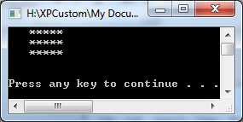

The output of Rectangle_1.cpp

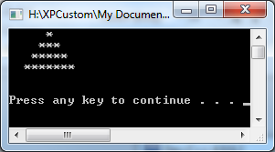

The output of Triangle_1.cpp

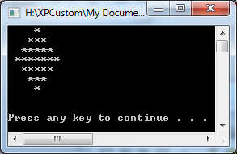

The output of Diamond_1.cpp

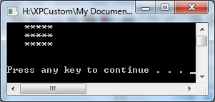

The output of Rectangle_2.cpp . The output is 3 spaces and 5 asterisks on each line, as I expected.

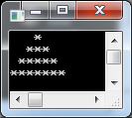

The output of Triangle_2.cpp which was made using the new commands printSpaces() and print Asterisks()

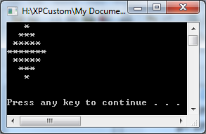

The output of Diamond_2.cpp using the new commands.

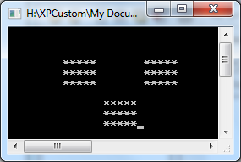

The output of the Rectangle_3.cpp file that I modified.

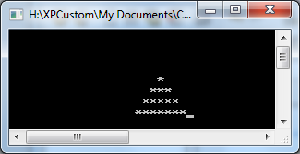

The left justified triangle output of the Triangle_3.cpp file.

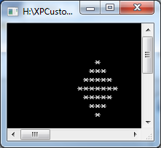

The center justified diamond output of the Diamond_3.cpp file.